**VISUALISING GAMING SURVEY**

**By TARUN REDDY NALLA**

**Section 1**

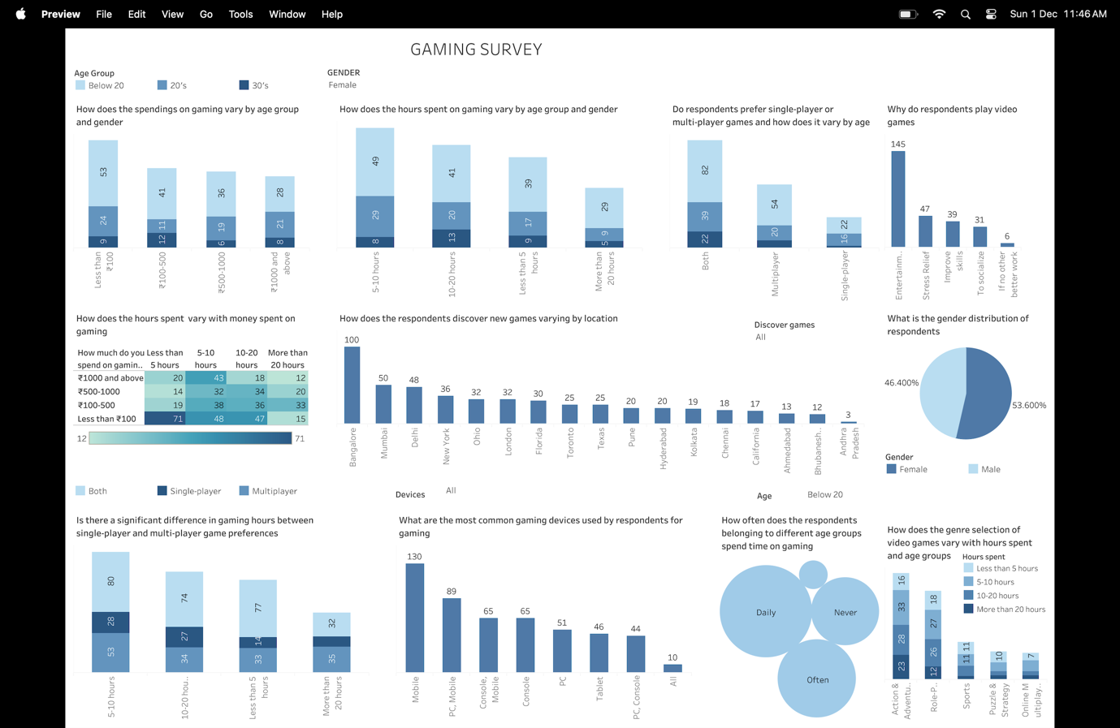

In order to help stakeholders make well-informed decisions that maximise user engagement (for example, through daily rewards or multiplayer modes), enhance product offerings (for example, genre-specific games or device-specific features), and increase revenue (for example, through targeted commercialisation and marketing), the dashboard converts raw data into actionable insights. It offers a comprehensive view of the gaming industry, enabling businesses to successfully innovate and maintain their competitiveness.

**Section 2: The Dataset**

This dataset includes answers to a survey that was done in 2024 to learn more about gamers' preferences, behaviours, and gaming patterns. The frequency of gaming, preferred devices, genres, and the amount of time and money spent on gaming are among the few topics it covers. Developers, marketers, and researchers can find trends and preferences in the gaming community with the use of this dataset, which offers insightful information on the gaming industry.

* The dataset has 500 rows and 22 columns.
* Column data types:

|  |  |
| --- | --- |
| **Column Name** | **Datatype** |
| Timestamp | Interval |
| Age | Ratio |
| Gender | Categorical |
| Location | Categorical |
| How often do you play video games? | Ordinal |
| How many hours do you typically spend gaming in a week? | Ratio |
| Which device do you play games on the most? | Categorical |
| What genres of video games do you play? | Categorical |
| What is your favorite game? | Categorical |
| How do you discover new games? | Categorical |
| Do you prefer single-player or multiplayer games? | Categorical |
| How much do you spend on gaming monthly | Ratio |
| Why do you play video games? | Categorical |

* The other 9 columns are the duplicates of the above mentioned columns and they can be dropped as they have Nan values.
* There were numerous duplication in the location column, such as Bangalore being listed as Bangalore. Thus, we combined these names into one. We categorised the single numeric values in the Age column into groups like Below 20, 20s, and 30s. In Devices column, there was data like Console(like PS4, Xbox), Hand held devices(Nintendo), which ultimately offer same games, so grouped them into console. We categorised the data from the "discover new games" column like YouTube and Twitch under "social media." And similar ways. Data such as 30 minutes, 0 minutes, and 1 hour are all classified under less than 5 hours in the hours column.

**Section 3: Dashboard Users**

* **Gaming Community Managers & Social Media Teams:** Utilise information about the reasons behind gaming to create community engagement plans and create audience-relevant content. The development of social media content, promotions, and community activities that suit to the interests of gamers can be guided by insights into game genres and devices. Community managers can concentrate on creating material and conversations around the most popular subjects among their followers by knowing their favourite games and genres.
* **Game Retailers & Online Marketplaces:** Utilise information about devices, spending patterns, and favourite genres to enhance recommendation systems and assist users in finding new games that suit their interests. To supply popular games and schedule promotions during busy times, examine user preferences and game purchase trends. Create loyalty programs that encourage recurring purchases and in-game transactions by leveraging information into spending trends and gaming behaviour.
* **Game Designers & User Experience (UX) Teams:** Create user experiences that complement player behaviours by using data on device usage and game choices (such as single-player versus multiplayer). Understanding the reasons behind gaming (such as competition or leisure) allows UX teams to give priority to features that improve these driving forces. Make use of demographic information about gamers to find testers who match target characteristics and make sure their input is pertinent to improving gameplay.

**Section 4: Questions**

* How does the spendings on gaming vary by age group and gender?
* How does the hours spent of gaming vary by age group and gender?
* Do respondents prefer single-player or multiplayer games, and how does this vary by age?
* Why do respondents play video games?
* How does hours spent vary with money spent on gaming?
* How do respondents discover new games varying by location?
* What is the gender distribution of gamers in the survey?
* Is there a significant difference in gaming hours between single-player and multiplayer game preferences?
* What are the most common gaming devices among respondents for gaming?
* How often does the respondents belonging to different age groups spend time on gaming?
* How does the genre selection of video games vary with hours spent and age groups

**Section 5: Plots**

1. How does the spendings on gaming vary by age group and gender?

**Question:** How does the spendings on gaming vary by age group and gender?

This bar graph illustrates the differences in game spending by gender and age groups (below 20, 20, and 30). The data shows spending trends, with gender and age having an impact on gaming expenditures.

1. How does the hours spent of gaming vary by age group and gender?

**Question:** How does the hours spent of gaming vary by age group and gender?

The distribution of gaming hours by gender and age group is shown in this stacked bar chart. It draws attention to the variations in gaming hours among different groups.

1. Do respondents prefer single-player or multiplayer games, and how does this vary by age?

**Question:** Do respondents prefer single-player or multiplayer games, and how does this vary by age?

The preferences of various age groups for single-player, multiplayer, and both kinds of games are contrasted in this bar chart. It demonstrates that the majority of responders favour both strategies.

1. Why do respondents play video games?

**Question:** Why do respondents play video games?

The motivations for playing video games are listed in this bar chart and include socialising, stress reduction, amusement, and skill advancement. The main explanation seems to be entertainment.

1. How does hours spent vary with money spent on gaming?

**Question:** How does hours spent vary with money spent on gaming?

This heatmap examines the correlation between gaming hours and spending, demonstrating that longer gaming sessions are associated with higher spending.

1. How do respondents discover new games varying by location?

**Question:** How do respondents discover new games varying by location?

This bar graph displays the regional breakdown of how respondents find new games. The most well-known place to find games is Bangalore.

1. What is the gender distribution of gamers in the survey?

**Question:** What is the gender distribution of gamers in the survey?

The percentage of male (53.6%) and female (46.4%) survey respondents is displayed in this pie chart.

1. Is there a significant difference in gaming hours between single-player and multiplayer game preferences?

**Question:** Is there a significant difference in gaming hours between single-player and multiplayer game preferences?

Players spend more time playing multiplayer games overall, according to this bar graph that compares the amount of time spent playing single-player and multiplayer games.

1. What are the most common gaming devices among respondents for gaming?

Question: What are the most common gaming devices among respondents for gaming?

The most widely utilised gaming devices, including tablets, PCs, consoles, and smartphones, are displayed in this bar chart. The majority of gaming is done on mobile devices.

1. How often does the respondents belonging to different age groups spend time on gaming?

**Question:** How often does the respondents belonging to different age groups spend time on gaming?

This bubble chart shows the frequency of gaming among various age groups. Higher gaming frequencies are represented by larger bubbles.

1. How does the genre selection of video games vary with hours spent and age groups

**Question:** How does the genre selection of video games vary with hours spent and age groups

This stacked bar chart illustrates the differences in genre choices (such as action, sports, and puzzle) according to age group and gaming hours.

**Section 6**

**Dashboard Interactivity**

1. **Age Group Filter**

* Allows the user to filter visualizations by specific age groups ((e.g., below 20, 20s, 30s, etc.)
* Connected plots: How often does the respondents belonging to different age groups spending time on gaming, How does the genre selection of the video games vary with hours spent and age group.
* Value Range: Categories: Below 20, 20s, 30s, etc., Loaded from the "Age Group" attribute in the dataset.
* A screenshot of a computer

  Description automatically generated

1. **Gender Filter**

* Allows the user to filter data by gender to observe trends specific to one or more genders.
* Connected Plots: How does the spendings on gaming vary by age group and gender, How does the hours spent on gaming vary by age group and gender, Do respondents prefer single-player or multi-player games and how does it vary by age group, Why do respondents play video games
* Value Range: Categories: Male, Female, Loaded from the "Gender" attribute in the dataset.
* A screenshot of a computer

  Description automatically generated

1. **Device Preference Selector:**

* Control: Checkbox for PC, Mobile, Console.
* Connected Plots: What are the most common gaming devices used by respondents for gaming.
* Value Range: PC, Mobile, Console, loaded from the "Preferred Device" attribute in the dataset, which lists the devices respondents use for gaming.

1. **Discover Games**

* Control: dropdown for selecting how respondents discover games
* Connected Plots: How does respondents discover new games varying by location.
* Value Range: Gaming forums, Recommendations, Self and Social Media.

